Bernardo B. Carvalho, Manfred Zilker

bernardo.carvalho@tecnico.ulisboa.pt

Abstract

This document describes the main hardware, firmware and software  
 features of the ATCA-MIMO-ISOL board in the W7-X Diamagnetic Interlock version.

ATCA-MIMO-ISOL   
User Manual

W7-X Diamagnetic Interlock version

|  |  |
| --- | --- |
| Revision: | 1.3 |
| Status: | To be approved |
| Repository: | https://gitlab.mpcdf.mpg.de/bcar/ipfn-atca |
| Document ID: |  |
| File: | ATCA-MIMO-ISOL-w7x-interlock_Manual.docx |
| Owner: | Carvalho, B. |
| Last modification: | June 28, 2018 |
| Created: | August 30, 2017 |

# Document history

|  |  |  |  |  |
| --- | --- | --- | --- | --- |
| **Revision** | **Date** | **Changed/**  **Reviewed** | **Section(s)** | **Modifications** |
| **0.1** | 2014-06-06 | A. Batista | All | JET-VS Version |
| **1.0** | 2017-09-13 | B. Carvalho | All | Updated for the W7-X Firmware |
| **1.1** | 2017-09-25 | M. Zilker | All | Some corrections + updates |
| **1.2** | 2017-09-28 | B. Carvalho | All | Some Corrections + update |
| **1.3** | **2018-**06**-28** | **B. Carvalho** | **All** | **Some corrections + updates** |
|  |  |  |  |  |

Table of Contents

Document history 1

2. Introduction 3

2.1. Related documents 3

3. Specifications 3

3.1. Analogue inputs 3

3.2. Trigger specifications 3

3.3. Clock specifications 3

3.4. Time stamping specifications 3

3.5. Processing capabilities 3

3.6. Host specifications 3

4. ATCA-MIMO-ISOL Description 4

4.1. Main Board Architecture 4

4.2. Analogue inputs 5

4.3. RTM Board 6

4.3.1. Digital IO with EIA-485, LVDS, LVTTL signal levels 7

5. ADC chopper Acquisition Module description 7

6. ATCA MIMO ISOL FPGA Firmware Description 8

6.2. Front Panel LEDS 9

7. Timing system 9

7.2. Data Processing 10

7.2.1. DMA Packet Format 12

7.2.1. DMA INTEGRATOR STATUS word Format 12

8. Board Registers 13

8.1. Main Register Map 13

8.2. Register Description 15

8.2.1. STATUS Register 15

8.2.1. COMMAND Register 15

8.3. Offset Registers Indirect Access 16

9. Software Description 16

10. Special Handling and Operation Considerations 16

# Introduction

A special version of the ATCA-MIMO-ISOL firmware was developed for the purpose of the Diamagnetic Interlock system for the W7-X Stellarator. The main goal is to measure up to 6 channels from the Diamagnetic Diagnostic and Rogowsky Coils, to compute in real-time (500 ns cycle) an estimate of the Plasma Internal Diamagnetic Energy and finally to generate an alarm signal in the form of a binary output signal if a threshold is reached. The inductor type sensors produce a voltage proportional to the magnetic flux time derivative. After these voltages are converted by the ADC the samples must be integrated numerically to recover the fluxes. The ATCA board uses the chopper based ADC modules (the input analogue signal is periodically subjected to a phase inversion), so a sample de-chopping procedure must be made before the numeric integration. Both the de-chopping and numerical integral are performed by the FPGA, including the correction for the integrator drifts.

This ATCA single width card comprises a main carrier board, the plugin isolated ADC modules and a rear transition module (RTM) mechanically connected together. Up to 12 cards can be inserted on an ATCA shelf.

## Related documents

* Carrier Board Schematic
* ADC chopper module Schematic.
* Code Repository   
  <https://gitlab.mpcdf.mpg.de/bcar/ipfn-atca/tree/master/virtex4/w7x-interlock-fp>

# Specifications

## Analogue inputs

* Number of channels: 32 (differential).
* Input impedance: > 100 kΩ.
* Voltage isolation: 1 kV.
* Dynamic ranges: See section 4.2.
* Resolution: 18 bits.
* Sampling rate: 2 MSPS.
* programmable phase chopping frequency
* Anti-aliasing filter: passive 3rd order low pass Butterworth 500 kHz.
* Connectors: Male D 37-way.

## Trigger specifications

* Master trigger: external or internal (software).
* External Trigger is negative edge, with a 500 ns minimum pulse width of.

## Clock specifications

Master sampling clock: 2 MHz generated on board; can be synchronized with external 10 MHz sync clock.

## Time stamping specifications

Time resolution: 1 µs.

Maximum time counter: over 30 minutes (2^32 x 500 ns).

## Processing capabilities

FPGA: Xilinx® Virtex™ 4 (XC4VFX60).

## Host specifications

Single front ATCA slot plus RTM slot.

ATCA Fabric channel 1 (x1 or x4 PCI Express).

The Master board on the ATCA crate connects to the RTM board



Figure 1 General view of the ATCA-MIMO-ISOL carrier board including one ADC at top (first) position.

# ATCA-MIMO-ISOL Description

## Main Board Architecture

The heart of the ATCA-MIMO-ISOL board is a XilinxTM FPGA XC4VFX60. The FPGA maximum processing power is roughly 80 GMACS.

External trigger and 10 MHz sync clock are connected to the master board which distributes the two signals via the ATCA backplane to the slave boards and back to the master itself. Figure 1 presents the architecture of the board and Figure 3 a general view.

The DDR memory SODIMM module is not used and should not be installed in the ATCA carrier.



Figure 2 ATCA-MIMO-ISOL block diagram

## Analogue inputs

The analogue inputs are connected in groups of 8 in the ATCA main Carrier front panel. For each group a D37 type connector is present. The connector pins of each analogue input channel can be found below:

Table 1

. 

## RTM Board

A simple custom RTM board was developed at IPP carrying no logic or complex data interfaces other than voltage converter chips for LVDS, LVTTL, and RS485 standards (Fig. 2). It connects to the back of the ATCA crate opposite to the (one and only one) master ATCA carrier. In the other it contains an D-37 to interface to the W-7-X TTE timing system.

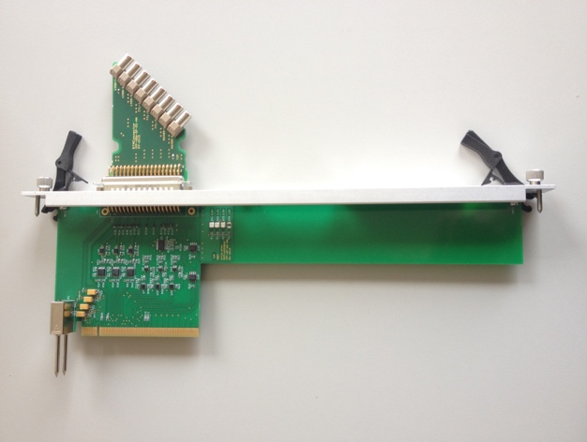

Figure 3. Simple RTM board” developed for W7-X CoDaC system.

### Digital IO with EIA-485, LVDS, LVTTL signal levels

The connector pins of each digital IO channel can be found below.

Table 2 RS485 Connector pin

|  |  |  |  |  |
| --- | --- | --- | --- | --- |
| **CHANNEL** | **NAME** | **PINS (+/-)** | **DIRECTION** | **SIGNAL LEVEL** |
| R1 | 10 MHz TTE Clock | 20/21 | INPUT (FPGA) | LVDS |
| R2 |  | 22/23 | OUTPUT (i2C) | LVDS |
| R3 |  | 24/25 | OUTPUT (i2C) | LVDS |
| R4 | TTE trigger Active Low | 26 | INPUT (FPGA) | LVTTL |
| D5 | 2 MHz ADC Sampling Clock | 28 | OUTPUT (FPGA) | LVTTL |
| 6 | ADC Chopper Clock OUT | 30 | OUTPUT (FPGA) | LVTTL |
| 7 | Interlock OUT | 32/33 | OUTPUT (FPGA) | RS-485/-422 |
| 8 | (Spare OUT) | 34/35 | OUTPUT (i2C) | RS-485/-422 |

# ADC chopper Acquisition Module description

The block diagram is shown in Fig. 3, showing the Signal Condition block with a passive filter attenuator and active differential amplifier, the ADC block (18-bit resolution, fixed 2MSPS), a DC-DC converter and Magnetic Isolation coupler (ILS711-S1) and finally the digital interface to the FPGA in the ATCA carrier Board. The FPGA provides the clock signals for the DC-DC converter, the chopper and ADC clock (common to all channels) and receives the serial ADC data and respective clock signals.



Figure 4. Block diagram of the phase modulated ADC module

The dynamic ranges, impedances, and filters cut-off frequencies can be adjusted by changing the passive components in the analog front end of the circuit. A set of custom ADC modules (Fig. 4) adapted for the different groups of W7-X magnetic probes were assembled industrially, in four different types as presented in Table 3.

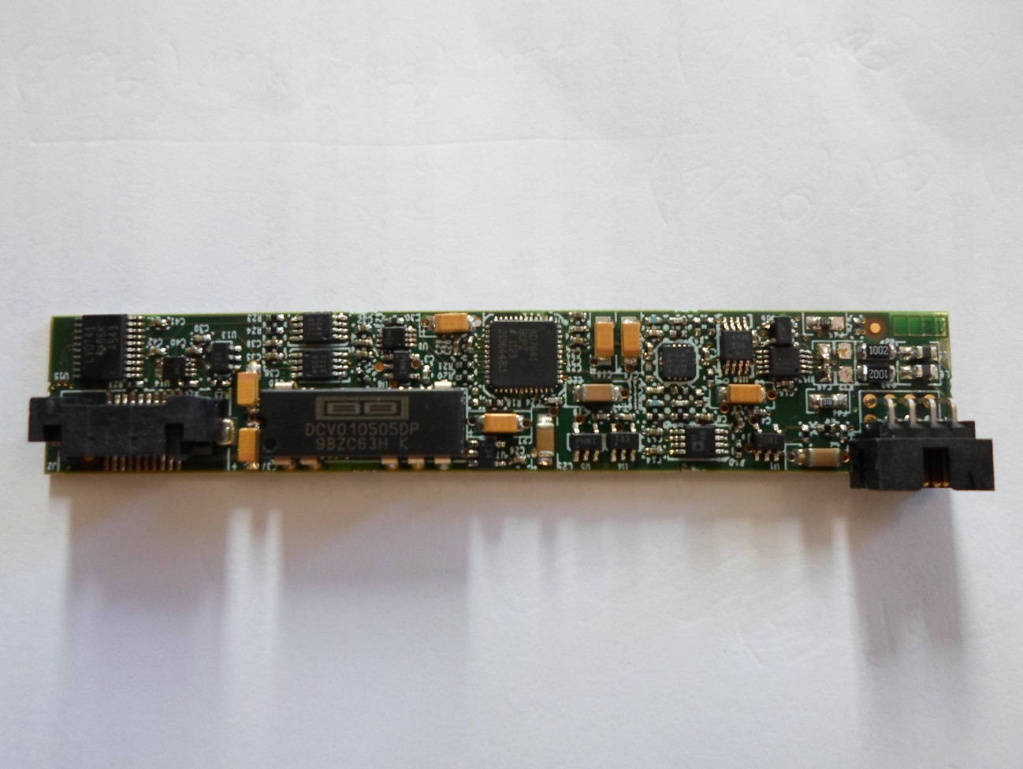

Figure 5 Galvanic isolated 2MSPS ADC module

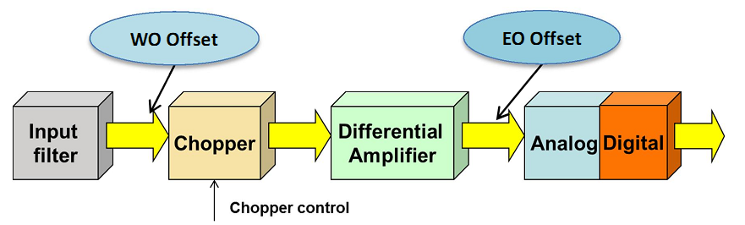

Figure 6 Diagram depicting the main sources of error in the numerical algorithm in the “chopper” based 2MSPS ADC module

Table 3 Chopper ADC module input filter configurations

|  |  |  |  |  |
| --- | --- | --- | --- | --- |
| **Type** | **1** | **2** | **3** | **4** |
| **Voltage range  / Vpp** | 71 | 4.4 | 252 | 16.5 |
| **Cut-Off Freq.  / Hz** | 925 | 940 | 840 | 1020 |
| **Number Modules** | 10 | 220 | 4 | 28 |

# ATCA MIMO ISOL FPGA Firmware Description

The Firmware for the ATCA-MIMO-ISOL is written in Verilog language and compiled using the XILIXNX ISE version 14.7 (last and definitive version of XILINX ISE compiler) on Windows OS. All the source codes are stored and versioned in the RZG IPP GIT server:  
<https://gitlab.mpcdf.mpg.de/bcar/ipfn-atca/tree/master/virtex4/w7x-interlock-fp>

The firmware implements a PCIe endpoint and the necessary logic to run the acquisition/processing. The PCIe DEVICE ID is “0024" (hex). The VENDOR_ID is the STANDART XILINX id (“10EE”hex). The PCI Express reset signal on the ATCA backplane (ATCA_RX_3A) is used to reset the FPGA logic.

The firmware is compiled to the bitfile format (*.bit) and converted to the *.ace format in order to be stored in a COMPACT FLASH (CF) card. An example IMPACT script is included in the folder ‘implement/’ that can be used to convert the bit to ace format. The filename follows the following format:

“id24_vXX.ace”, where ‘XX’ is the Firmware version number.

The firmware is capable of changing the chopping frequency or to cancel the chop modulation.



Figure 7 Block schematic of the Interlock FPGA firmware

## Front Panel LEDS

The board includes two front Panel LEDS, a blue and a YELOW one. The connections are  
BLUE LED: PLL status. Should be ON if 10 MHz is connected and internal PLL is LOCKED

YELOW LED: Should blink at ~1s period in IDLE Mode. When acquiring and streaming data to PC is blinking at a faster (~4Hz) rate.

# Timing system

The timing logic is adapted to the W7-X timing system in order to be compatible with other firmware version running in the same crate. The external clock (10 MHz) and external trigger are connected to the master board and distributed to the other boards (and also to the master board itself) via the ATCA backplane. The master board is automatically assigned if it the RTM board is connected. When the external clock is not present on the master board an internal 2 MHz clock is automatically generator used.

The external trigger or the software trigger resets the time counter.



Figure 8 Clock configuration presently used at W7-X ATCA acquisition system

## Data Processing

The firmware is able to perform for each individual input channel the phase recovering:

$$s_{i}\left[n\right]=\left({Vadc}_{i}\left[n\right]-{eo}_{i}\right)∙ {Ph}_{chop}\left[n\right]$$

Where *Pchop[n]* the phase signal of the chopper, being either *1* or *-1*. Then the integral is performed which includes the drift correction:

$$Φ_{i}\left[n\right]=\sum_{k=0}^{n}{\left.{\left(s_{i}\left[k\right]{-wo}_{i}\right)}_{}\right.}$$

The integral in performed in fixed point arithmetic. The values *Vadci[n]* and *eoi* are integers so the calculation in done full precision. The integral drift correction *woi* is performed with 16 bit fractional bits.

After the integration the firmware is able to convert the *si[n]* values to floating point and to perform the energy calculation:

$$F\left[n\right]=\sum_{i=0}^{5}{c_{i}{∙Φ}_{i}\left[n\right]}+ c_{6}$$

The Interlock firmware performs the next processing steps for each channel, as depicted in Figure 9:

1. A subset of 6 of the input channels are acquired at full resolution (18 bit) and de-serialized each 500 ns.
2. The correction of EO offset is performed in the FPGA.
3. The sign of the corrected value is changed if the chop signal is 1
4. This value plus the WO offset (integral drift) is added to the Accumulator. The WO has 16 fractional bits, so it should be created from a float value, multiplied by 2^16, then extract the integer float and convert to 32 bit integer (eg. *round()* function).
5. A Spike removal mechanism is implemented. At each chopping phase change the 3 subsequent fresh samples are discarded and the last “good” sample is used for the integral summation.
6. At each sample processing a check is made if the Accumulator overflows.
7. Accumulator value is converted to IEEE 754 32 bit float number format
8. Special registers will be created for storing the correcting offsets.



Figure 9 Data Processing for each acquired channel

After the computation of the accumulator for each channel the DSP processing is done completely in floating point format, following the next steps as Figure 10:

1. Each channel is multiplied by coefficient stored in the firmware. An overflow situation is recorded
2. Pairs of channels are summed together to form 3 intermediate values
3. The first two intermediate values are summed.
4. This last intermediate value (float number) is transmitted to the PC in the DMA packet position 12
5. The Absolute Value of the Energy is taken of the last intermediate value
6. Absolute value is subtracted to the addictive coefficient #6. This last coefficient should be regarded as a reference value (threshold).
7. Finally, the “Energy Calculation” minus the reference is computed. The interlock output signal is extracted as the inverse of the sign bit and sent in to the pin 7 of the EIA-485 digital IO RTM connector. (Logic “1” For positive values)
8. The entire float is transmitted to the PC in the DMA packet position 13.



Figure 10 Data Processing for Energy calculation

The integrator drift will be also compensated using the values calculated offline. The 6 channels integrated signals will be grouped in packets and streamed in DMA transfers of 4MB size (65536 samples)

### DMA Packet Format

Data streaming is organized in 4MB chunks of data, each carrying 65536 time samples at 2MSPS (~32ms/DMA). For each sample (64 Byte) data is organized as 16 x 32 bit data words:

|  |  |  |  |
| --- | --- | --- | --- |
| **DMA DATA WORD** | **DESCRIPTION** | **FORMAT** | **Comment** |
| 0 | ADC RAW CHANNEL 0 | INT_32 (18 sign extended) |  |
| 1 | ADC RAW CHANNEL 2 | “ |  |
| 2 | ADC RAW CHANNEL 4 |  |  |
| 3 | ADC RAW CHANNEL 6 |  |  |
| 4 | ADC RAW CHANNEL 8 |  |  |
| 5 | ADC RAW CHANNEL 10 |  |  |
| 6 | ACCUMULATOR CHANNEL 0 | FLOAT_32 |  |
| 7 | ACCUMULATOR CHANNEL 2 | FLOAT_32 |  |
| 8 | ACCUMULATOR CHANNEL 4 | FLOAT_32 |  |
| 9 | ACCUMULATOR CHANNEL 6 | FLOAT_32 |  |
| 10 | ACCUMULATOR CHANNEL 8 | FLOAT_32 |  |
| 11 | ACCUMULATOR CHANNEL 10 | FLOAT_32 |  |
| 12 | RAW ENERGY CALC | FLOAT_32 |  |
| 13 | ABSOLUTE VALUE ENERGY CALC – THRESHOLD PARAMETER | FLOAT_32 |  |
| 14 | INTEGRATOR STATUS | BIT FIELD (see next Table) |  |
| 15 | SAMPLE COUNTER | UINT_32 | Reset on the soft/hard trigger |

### DMA INTEGRATOR STATUS word Format

|  |  |  |
| --- | --- | --- |
| **BIT (0:LSB, 31:MSB)** | **NAME** | **DESCRIPTION** |
| 31 | INTERLOCK STATUS | Reflects output on the I/O pin |
| 30 | ACCUM. CHANNEL OVERFLOW 0 | Should be 0 |
| 29 | ACCUM. CHANNEL OVERFLOW 2 |  |
| 28 | ACCUM. CHANNEL OVERFLOW 4 |  |
| 27 | ACCUM. CHANNEL OVERFLOW 6 |  |
| 26 | ACCUM. CHANNEL OVERFLOW 8 |  |
| 25 | ACCUM. CHANNEL OVERFLOW 10 |  |
| 24 | DSP ADD BLOCK 1 OVERFLOW |  |
| 23 | DSP ADD BLOCK 2 OVERFLOW |  |
| 22 | DSP ADD BLOCK 3 OVERFLOW |  |
| 21 | DSP ADD BLOCK 4 OVERFLOW |  |
| 20 | DSP ADD BLOCK 5 OVERFLOW |  |
| 19 | DSP ADD BLOCK 6 OVERFLOW |  |
| 18-1 | NOT USED |  |
| 0 | ADC_CHOP | Reflects the ADC chopping signal of the present sample |

# Board Registers

## Main Register Map

The FPGA includes and PCIe Endpoint which includes two BAR Memory Regions accessible through host driven PIO memory read/write 32-bit operations (non-cacheable). BAR 0 is currently reserved but not used on these firmware. BAR1 region maps a series of internal registers that are used to govern the Board operation. The main register map is shown on the following table:

|  |  |  |
| --- | --- | --- |
| **Register Name** | **Byte Address Offset (hex)** | **Comment** |
| STATUS | 0000h | See section bellow |
| COMMAND | 0004h | See section bellow |
| NOT USED | 000Ch | Not Used |
| DMA CURRENT BUFFER | 0010h | For DMA internal engine use |
| HW_COUNTER | 0014h | Time counter |
| NOT USED | 001Ch | Not Used |
| DMA ADDRESS 0 | 0020h | Stores Host PC MEM physical Address or DMA buffer #0 |
| DMA ADDRESS 1 | 0024h | ‘’ |
| DMA ADDRESS 2 | 0028h | ‘’ |
| DMA ADDRESS 3 | 002Ch | ‘’ |
| DMA ADDRESS 4 | 0030h | ‘’ |
| DMA ADDRESS 5 | 0034h | ‘’ |
| DMA ADDRESS 6 | 0038h | ‘’ |
| DMA ADDRESS 7 | 003Ch | ‘’ |
| DMA ADDRESS 8 | 0040h | ‘’ |
| DMA ADDRESS 9 | 0044h | ‘’ |
| DMA ADDRESS 10 | 0048h | ‘’ |
| DMA ADDRESS 11 | 004Ch | ‘’ |
| DMA ADDRESS 12 | 0050h | ‘’ |
| DMA ADDRESS 13 | 0054h | ‘’ |
| DMA ADDRESS 14 | 0058h | ‘’ |
| DMA ADDRESS 15 | 005Ch | ‘’ |
| N_BYTES | 0060h | Number of bytes in each DMA transfer |
| NOT USED | 0064h – 0074h | Not Used |
| DAC1 | 0078h | Not Used |
| DAC2 | 007Ch | Not Used |
| DAC3 | 0080h | Not Used |
| DAC4 | 0084h | Not Used |
| DAC5 | 0088h | Not Used |
| DAC6 | 008Ch | Not Used |
| DAC7 | 0090h | Not Used |
| DAC8 | 0094h | Not Used |
| NOT USED | 0098h | Not Used |
| NOT USED | 009Ch |  |
| CHOP_MAX_COUNT | 00A0h | Used to set Chopping frequency (2000: *f*=1kHz) |
| CHOP_CHANGE_COUNT | 00A4h | Used to set Chopping Duty Cycle (should be 50% of CHOP_MAX_COUNT) |
| NOT USED | 00A8h – 00C4h |  |
| REG_OFFSET | 00C8h | Indirect Access. See section 8.38.3 |
| REG_DATA | 00CCh |  |

|  |  |  |
| --- | --- | --- |
|  |  |  |

## Register Description

### STATUS Register

Table 4 Status register Bit fields

|  |  |  |  |
| --- | --- | --- | --- |
| **Bits** | **Name** | **Description** | **Values** |
| 31-24 | NOT USED |  |  |
| 23 | NOT USED |  |  |
| 22 | AD9511_STATUS | 10 MHz PLL LOCKED | “1” with TDC 10 MHz locked |
| 21 | MASTER | BOARD IS ATCA MASTER CLOCK | Should read as 1 if RTM board is connected |
| 20 | MSI_ENABLE | MSI INTERRUPTS are enabled | Should read as 1 |
| 19-16 | Slot ID | Logical Slot ID (4 bits) | Read by Board |
| 15 | Stream Enable BIT | used for FW  debugging | Should be the same as COMMAND Reg. Bit 19 |
| 14-8 |  | used for FW  debugging |  |
| 7..0 | FW_VERSION | FW_VERSION | At the date of this doc: 0xB4 |

### COMMAND Register

Table 5 CONTROL register Bit fields

|  |  |  |  |
| --- | --- | --- | --- |
| **Bits** | **Name** | **Description** | Value (**Bold**: default) |
| 31 | ACQiE | NOT USED |  |
| 30 | DMAiE | NOT USED |  |
| 28-27 |  | NOT USED |  |
| 27 | DMAE | NOT USED |  |
| 26-25 |  | NOT USED |  |
| 24 | STRG | Soft Trigger |  |
| 23 | ACQE | Acquisition Enable |  |
|  |  |  |  |
| 19 | STREAME | Enable Data Streaming by DMA | (**0:OFF** , 1: OFF) |
|  |  |  |  |
|  |  |  |  |
| 12 | CHOP_RECONSTRUCT |  |  |
| 11 | CHOP_DEFAULT |  |  |
| 10 | CHOP_ON |  |  |
|  |  |  |  |
| 8 | ENDIAN_DMA | Endianness of DMA data words | (**0:little** , 1: Big Endian) |
| 7-0 |  | NOT USED |  |

## Offset Registers Indirect Access

Due to the lack of available address for internal FPGA registers an indirect read/write mechanism was implemented to store the EO, and WO offset parameters and DSP coefficients.

To write/read on these registers the software must write first on the REG_OFFSET register the corresponding address according to the following Table

Table 6 Indirect Register Addresses

|  |  |  |
| --- | --- | --- |
| **REG_OFFSET value (HEX)** | **INDIRECT REGISTER** | **FORMAT** |
| 0000h | EO Offset CHANNEL 0 | INT 32 |
| 0001h | EO Offset CHANNEL 2 |  |
| 0002h | EO Offset CHANNEL 4 |  |
| 0003h | EO Offset CHANNEL 6 |  |
| 0004h | EO Offset CHANNEL 8 |  |
| 0005h | EO Offset CHANNEL 10 |  |
| ……. | …. |  |
| 0020h | WO Offset CHANNEL 0 | INT 32 – See section 7.2, point 4 |
| 0021h | WO Offset CHANNEL 2 |  |
| 0022h | WO Offset CHANNEL 4 |  |
| 0023h | WO Offset CHANNEL 6 |  |
| 0024h | WO Offset CHANNEL 8 |  |
| 0025h | WO Offset CHANNEL 10 |  |
| …. | … |  |
| 0040h | DSP MULTIPLIER CHANNEL 0 | FLOAT 32 |
| 0041h | DSP MULTIPLIER CHANNEL 2 |  |
| 0042h | DSP MULTIPLIER CHANNEL 4 |  |
| 0043h | DSP MULTIPLIER CHANNEL 6 |  |
| 0044h | DSP MULTIPLIER CHANNEL 8 |  |
| 0045h | DSP MULTIPLIER CHANNEL 10 |  |
| 0046h | DSP ENERGY THRESHOLD | FLOAT 32 |

# Software Description

A basic Linux software package is included in the ‘Software’ Folder. It consists on a Linux device driver, a collection on library functions and an example test application (‘apps/acqDataProc.c’). They should compile on Debian/Red HAT/Centos Linux with a recent kernel version (>= 3.10). The driver’s “Makefile” requires the kernel headers installed. When the driver is compiled and installed on the system, the OS should recognise the board and create a “device node” with the name: ‘/dev/atca_ioc_ilckX’, where ‘X’ is the ATCA slot logical number. See Table 7

Table 7 ATCA Slot Numbering on 14 slot Crates

|  |  |  |  |  |  |  |  |  |  |  |  |  |  |  |
| --- | --- | --- | --- | --- | --- | --- | --- | --- | --- | --- | --- | --- | --- | --- |
| Physical | 1 | 2 | 3 | 4 | 5 | 6 | 7 | 8 | 9 | 10 | 11 | 12 | 13 | 14 |
| Logical | 13 | 11 | 9 | 7 | 5 | 3 | 1 | 2 | 4 | 6 | 8 | 10 | 12 | 14 |

Some Gnuplot scripts are include to rapidly generate plots on X terminal of the raw Channel and Integrated data, but care has to be taken for Endianness of data.

# Special Handling and Operation Considerations

Due to sensitive devices on the module some precautions must be taken when handling and operating the board. Failed to comply with these procedures may result in hardware damage and/or malfunction.

1. Observe electrostatic precautions when handling the boards. Electronic components (especially analogue circuits) are sensible to ESD.
2. Use the board on good ventilated computer cases. Temperature above 65º C (die temperature) may cause permanent board damage.